Instructions to Applicants
Applicants should note the following instructions for preparing their Application:
- Applicants must read and consider the CRP Information Pack and How To Apply before completing this Application Form.
- Applicants must complete every section of this Application Form. Where not applicable please indicate N/A.
- If you have any questions about this Application, please direct them to tenders@containerexchange.com.au

Applicant Details
Applicants are required to provide the details outlined in the table below.
General Information on the Applicant’s representative
Full Name
Position title
Email
Phone Number
Role in Entity
General information about Entity
Name of Entity
Trading Name
ABN / ACN

Registered Address
Website
Does the entity currently have a contract with COEX to operate within the scheme. | ☐ Yes  If Yes - please provide type of contract:  ___________________  ☐ No
Entity Contact Details (if different from above)
First Name
Surname
Email
Phone Number
Type of entity (must be a registered company (Pty Ltd or Ltd) Local Council or Incorporated Association) | ☐ Company  ☐ Other: ______________________________
Is the entity a subsidiary entity? If so, please provide the name of the ultimate holding company and its ABN/ACN.
Is the entity a not-for-profit organisation? | ☐ Yes  ☐ No
If the application is made on behalf of a consortium, please name all entities comprising the consortium and provide their ABN/ACN.
Nature of the Applicant’s current business
Provide an overview of the Applicant including type of industry, sector, nature of work and scope of operations and operational history.

How many employees (by headcount & FTE) does the Applicant currently employ?

Capability
Relevant experience
Provide details of the Applicant’s experience in running a business of a similar scale in terms of revenue turnover and number of employees and/or complexity as the Services.
Note that relevant experience is not limited to waste collection and management.
Capacity
Provide details of the Applicant’s operational and financial capacity to deliver the services, including staffing levels and available working capital reserves.
In your response, please identify any other existing obligations the Applicant has and how this will be managed to ensure no impact on the delivery of Services.
Financial Statements
Attach the Applicant’s:
- Most recent audited Financial Statement/s, if available; or
- Financial Statements from the last 3 years
NOTE: If the applicant is an existing Operator only the most recent Financial Year statement is required.

Proposed Container Refund Point (CRP)
Applicants must provide details of the proposed CRP including Drop-off’s and Mobile Container Refund Points.
Are you applying for more than one CRP? If so, please complete a separate copy of section 3 for each CRP proposed.
Response Requirement | Response
Proposed CRP address  Insert the specific street address, including unit number, street number, street name, suburb, postal code. | Street: _____________________  Suburb: ____________________  Postcode: __________________
Proposed operational commencement date
Insert the date on which this CRP will be ready to commence operations.
Type of CRP proposed  Detail the type of CRP proposed. Refer to Section 3.2 of the CRP Information Pack for further information relating to CRP types. | ☐ Traditional ‘depot-style‘  ☐ Drop-Off  ☐ Mobile  ☐ Reverse Vending Machines (RVMs)
CRP proposed opening hours
Detail the proposed operating hours/ days for the CRP
Planning and Licensing requirements
Detail any planning approvals or consents required or already obtained for the proposed CRP. Include applications for a license to operate as a waste management business.
Note: it is the responsibility of the Applicant to ensure that appropriate zoning considerations are complied with, including for the provision of waste services, traffic impacts and other planning issues.
Current ownership or lease status
Detail the current ownership or lease status of the proposed CRP, including, if relevant, proposed lease term and whether it has been secured or is subject to further agreements.
CRP Location Description
Describe the current state of the proposed location i.e. occupied or vacant and details of the current operation and purpose for which the location is being used for (e.g. retail operations), if applicable.
Is the Applicant, after making reasonable enquiries, aware of any asbestos in proposed CRP location. | ☐YES ☐NO  If Yes, please provide :any information you have on where asbestos can be found on the site
Capability of the location
Detail the following:
- Type of collection infrastructure proposed for the CRP including cages, bins etc
- staffing levels required to operate the CRP

Description of customer service interface
Detail how the Applicant intends to configure the CRP to service customers i.e. members of the public presenting eligible containers.
Include details on:
- type of CRP e.g. for a traditional ‘depot-style’ CRP, where members of the public can drive into the CRP, please describe how many service lanes and counting bays be available to customers.
Description of logistics interface
Detail how the Applicant intends to configure the CRP to allow for pickup of containers by the Logistics Provider.
The response should include how the Applicant will securely store sorted containers and how logistics providers will access and collect the sorted materials (i.e. truck access to CRP, size of space for truck access, truck turning space, security considerations, etc).
Note: CRPs are expected to store collected containers separated by material type in the collection infrastructure arranged by COEX.
Operational Plans
Detail the proposed traffic flow for the CRP and the plans for managing safety of employees and customers.

Approach to mobilisation
Detail the Applicant’s approach to mobilising the CRP for deliver to the Services.
Include:
- details of any material risks or issues identified that may impact on the ability to mobilise to deliver the Services, and the proposed approach to mitigating these risks or issues; and
- Estimated time-frame for mobilisation
Predicted Volume
Detail the predicted volume per annum for the CRP in relation to the area it would be servicing. Please include any data and analysis used.
Servicing the Community
Detail how the Applicant will engage and service the local community.
What are the Applicant’s capabilities for keeping up with growth in area, both with commercial businesses and population.

Marketing and Branding
Detail how the Applicant will apply the Containers for Change brand and create awareness within the community of your CRP.
Please provide a mar artist expression on how the site will look
Additional information
Provide any additional information that would support the selection of the CRP as an effective CRP.
CRP Manager Details
Full name
Email
Phone Number

Compliance Details
Compliance
Applicants must provide their history in relation to complying with legislative and regulatory obligations by responding to the following table. Where the Applicant is more than one entity, each entity comprising the Applicant must provide responses to the questions. Please provide responses in the right-hand column.
Details of any material regulatory or law enforcement agency investigations against the Applicant or any of their related entities including the ultimate holding company. This includes any investigations arising as a result of safety incidents and privacy related incidents.
Details of any material instances of contract termination against the Applicant or any of their related entities including the ultimate holding company.
Details of any material current or pending litigation against the Applicant or their related entities including the ultimate holding company.
Details of any liquidation or deregistration proceedings against the Applicant and for the Applicant’s ultimate holding company (if relevant) since the date of their last audited financial reports.
Details of any material contingent liabilities of the Applicant.
Details of any recent or imminent mergers/acquisitions which can be released.
Any other events or factors that could have a material impact on the financial capacity and standing of the Applicant or any of its related entities including the ultimate holding company.
Does the Applicant, its representatives or any other entities associated with the application have existing relationships with COEX employees or other operators in the Containers for Change Scheme which could give rise to a conflict of interest?

If so, please complete section 4 of the Application Form

Note: Failure to disclose any actual, potential or perceived conflict of interest with regards to the Containers for Change Scheme or COEX may result in an immediate rejection of the application.
Details of any policies, procedures or strategies of the Applicant and their ultimate holding company (if applicable) to facilitate compliance with the Modern Slavery Act 2018 (Cth).

OPTIONAL: COEX Asset Leasing Program Application
Pilot program – COEX Asset Leasing Program
COEX is currently running a limited pilot program offering eligible operators the chance to obtain customer-facing collection infrastructure via a lease-to-own type arrangement.
Will the CRP application be contingent on the pilot COEX Asset Leasing Program? | ☐YES ☐NO  If no, skip to section 5 of the application.
What collection infrastructure is the Applicant seeking under the pilot program?
If known (and discussed with COEX tenders) what is the price range of this asset?
Size and scale of operations  Using the eligibility criteria outlined in section 5.4 of the CRP Information Pack, please identify what the size of the Applicant entity is? | - Small Organisations  - Medium Organisation  What lease term are you seeking? _____________  Are you seeking monthly instalment payments that vary from the standard model outlined in section 5.2 of the application pack? ☐YES ☐NO
Strategic Alignment
Provide details outlining the intended use of the leased asset to drive scheme impact. Demonstrate alignment with COEX’s vision of ‘No Container Goes to Waste’.
Financial Capacity  Provide details of your organisation’s financial capacity to meet lease payment obligations. | Please Note this will be assessed based on documentation provided under section 2: Financial Statements
Operational Capacity
Provide details on how the Applicant plans to maintain the collection infrastructure. In the case of RVMs this will need to include daily maintenance. Maintenance includes cleaning, servicing, repairs.
Where relevant, provide details for how the Applicant plans to undertake secondary sorting of containers in preparation for processing.
Customer and Community
Provide details demonstrating how the Applicant plans to drive an optimal customer experience with the asset.
Provide details demonstrating active community initiatives and community partnerships.

Conflict of Interest Declaration
This declaration details any conflicts of interest that the Applicant, its representatives or employees may have with the Containers for Change Scheme or COEX.
Declaring a conflict of interest will not exclude the application. It will assist COEX to ensure that the Conflicts of Interest are managed appropriately. Failure to declare a Conflict of Interest may result in the application being discontinued.
Actual, potential or perceived conflicts of interest can occur at any time and are a normal part of life. However, it is important that you, as the Applicant’s representative, identify and declare any actual, potential or perceived conflicts of interest. If in doubt, it is recommended that you make the disclosure.
Applicant’s Business Name
[Insert Applicant’s Name]
Conflicts of Interest
I, as an authorised representative of the Applicant, am aware of the importance of disclosing conflicts of interest and I understand that the obligation to disclose such conflicts is a continuing obligation throughout this application process. I declare as follows:

☐ After making reasonable enquiries and to the best of my knowledge, there are no potential, perceived or actual conflicts of interest between our organisation (including the employees of our organisation) and other operators associated with the Containers for Change Scheme or COEX including the following:
- Container Refund Point Operators (CRP Operators)
- Processing Providers
- Material Recovery Facilities Operators (MRFOs)
- Recyclers
- Employees or Director of COEX
OR
☐ I am aware of potential, perceived or actual conflicts of interest between the Applicant (or its representatives and employees) and other operators within the Containers for Change Scheme or COEX and these conflicts are disclosed below.

☐ I undertake to disclose to COEX through my Network Delivery Lead for the region Business Development Team any further conflicts of interest issue which may arise throughout this application process.
Acknowledged: | [Full Name] |  | [Signature] | [Date]
Conflicts of Interest Issues
Disclose any actual, potential or perceived conflicts of interest with regards to existing participation to Containers for Change Scheme.  Provide details of related parties/ interested parties. Interested parties are considered as any party where scheme material is held, stored, or recycled.  To ensure that scheme integrity is not comprised, disclose safeguards that can be put in place to reduce the risk to an acceptable level. |  | [Applicant to outline how they propose to manage the risks and conflicts of interest (noted above) and what safeguards will be established to support the consideration of this application]

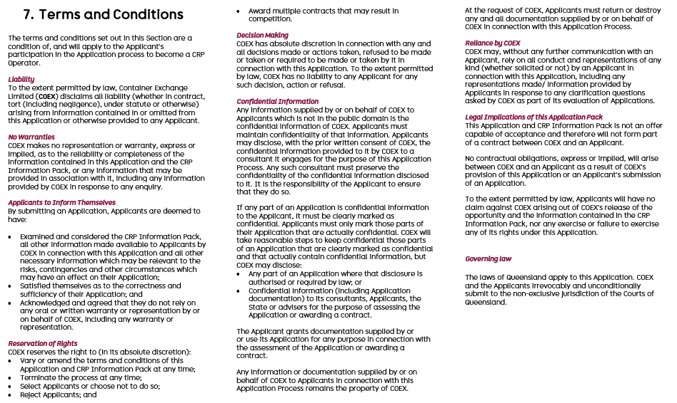

Application Acknowledgment
Applicants must complete the acknowledgement, consent and declarations below.
Queensland Container Refund Scheme – CRP Operator Application Acknowledgment
In submitting this Application to COEX, I [Insert name of Applicant Representative], authorised representative of the Applicant confirm and declare as follows:
- this Application is true and accurate;
- I am aware that if any information provided is incorrect that there may be grounds to terminate this application and rescind any contracts awarded on the basis of this information;
- I agree to the Terms and Conditions related to this application process set out in section 7 of the Application form (Terms and Conditions);
- I authorise COEX to perform relevant background and criminal history checks it deems appropriate by COEX based on information provided in this Application.
- I confirm that I have the express consent for COEX to perform any relevant background and criminal history checks on any individuals related to this Application, and.
- I authorise COEX to perform any financial searches required to assess the eligibility of the Applicant for the Asset Leasing Program and agree to submit or complete any further consent forms required for this purpose (if applicable).

_________________________
[Signature of Applicant signatory]
[Applicant name]
[Applicant address]

COMPLETED APPLICATIONS TO BE EMAILED TO: COEX - tenders@containerexchange.com.au

